**SUPERIOR UNIVERSITY LAHORE**

|  |
| --- |
| Superior Logo |

**Faculty of Computer Science & IT**

**Final Year Project**

**PROJECT REPORT (Part-1)**

**[PMAN (project manager)]**

Project ID:**[FYP20-GROUP-027]**

**Project Team**

|  |  |  |  |  |
| --- | --- | --- | --- | --- |
| **Student Name** | **Student ID** | **Program** | **Contact Number** | **Email Address** |
| Muhammad Samran Tanveer | Bcsm-f16-226 | BSCS | 03134125665 | Bcsm-f16-226@superior.edu.pk |

**[**Sir Muhammad Zaman Aziz**]**

([Lecturer])

# Chapter 2

# Software Requirement Specifications

**Chapter 2:** Software Requirement Specifications



## Introduction

## Purpose

The main purpose of Feed the Needy is to reduce the wastage of food and feed the poor and needy people. Food wastage is the sum of waste food and food lost. As most of the food is lost, statistics have shown that 36 million tons of food wasted every year only in Pakistan. About 40% of food wasted by cafes, restaurants, and in other functional gatherings. So cafes and restaurants can register on the website and volunteering NGO`s and needy people will also register on the server. NGO`s will pick up food from cafes and restaurants and will transport food to the food points (needy people).

## Document Conventions

This document features some terminology which readers may be unfamiliar with. This document follows MLA Format. Bold-faced text has been used to emphasize section and

Sub-section headings. Highlighting is to point out words in the glossary and italicized text is

Used to label and recognize diagrams.

## Intended Audience and Reading Suggestions

This document is to be read by the development team, the project managers, marketing staff, testers and documentation writers. Our stakeholders, company manufacturing associated web applications, company providing embedded operating system and distributors who markets the finished product, may review the document to learn about the project and to understand the requirements. The SRS has been organized approximately in order of increasing specificity. The developers and project managers need to become intimately familiar with the SRS. Others involved need to review the document as such:

Overall Description – Marketing staff have to become familiar to the various product features in order to effectively advertise the product.

System features – Testers need an understanding of the system features to develop meaningful test cases and give useful feedback to the developers.

External Interface Requirements – The hardware developers need to know the requirements of the device they need to build. The marketing staff also needs to understand the external interface requirements to sell the product by describing the user-friendly features of the travel.

Non-functional and Functional Requirements – The hardware developers:

## Product Scope

Feed the Needy is the first ever web application that provides an opportunity for cafes and restaurants to not to waste their food which can be fed to the poor and needy people around city/country. The needy people, cafes/restaurants and volunteering NGOs will have to register on the server to propose their services for the needy people. With this the wastage food can be lowered significantly and the issue of food shortage and hunger of the poor people can be solved to a very extent.

• Needy people will register on the server and will be stored as food points with their credentials and location.

• Cafes and restaurants will also register on the server with their locations, phones numbers. They`ll pack food with quantity of food and will give a thumbs up to the delivering company/NGO.

• Volunteering NGO or any food delivering company will pick up the food and will deliver it to the provided food points.

## References

Please consult the attached project scope document for further information regarding project scope. A use case diagram has been attached to accompany sections 2.1: Product

Perspective and 2.2: Product Features. A user manual is included to accompany section 2.6: User documentation. Product mock-ups and Requirements Validation Plan have also been included for general reference.

## Overall Description

## Product Perspective

Feed the Needy is the first ever web application that provides an opportunity for cafes and restaurants to not to waste their food which can be fed to the poor and needy people around city/country. The needy people, cafes/restaurants and volunteering NGOs will have to register on the server to propose their services for the needy people. With this the wastage food can be lowered significantly and the issue of food shortage and hunger of the poor people can be solved to a very extent.

• Needy people will register on the server and will be stored as food points with their credentials and location.

• Cafes and restaurants will also register on the server with their locations, phones numbers. They`ll pack food with quantity of food and will give a thumbs up to the delivering company/NGO.

• Volunteering NGO or any food delivering company will pick up the food and will deliver it to the provided food points.

## Product Functions

**Site Search & Browse:**

You have to offer quick search and browse response for all the stakeholders of this application.

You also have to provide a quick check-in for all the food points, restaurants and delivering company. Our web application also provides a filter search option by which the needy people can easily search that if there`s any restaurant/café ready to deliver food, café/restaurants can see whether there`s any food point and NGO delivering can see which restaurant is ready and which food point is there to deliver the food.

**Registry:**

There will be registry and a record of regular food points and restaurants/cafes. The convention of this will be that the delivering NGO will have to just pick up the food and deliver it to the food point.

**Inventory:**

The restaurants will have to mention that of how many persons food they are packing. After delivering at the food points if there`s still food left then it will be stored in the NGO`s inventory.

**Online Communication:**

There will be online communication between the food points and food delivering NGO, NGO and cafes/restaurants. The needy people can contact the NGO and vice versa. NGO can contact the cafes/restaurants and vice versa.

**Website Security:**

Choose best security method for the Feed the Needy to prevent from online attacks. For that kind of attacks, we use built-in SSL data encryption for security. When online inteface display this Secure Socket Layer (SSL) data encryption method Certificate seals on their home pages, users feel confident that their personal information will be protected. To develop this online waste food management system web application the most common thing that kept in mind is the user’s satisfaction to earn user’s loyalty. A web application firewall stops automate attacks that commonly target small or lesser-known websites.

## User Classes and Characteristics

## Operating Environment

The web application will operate with the following specifications:

The application being developed will be running under minimum Windows 7 or later OS, Microsoft Internet Explorer 11.0 or later, Google Chrome latest edition, Mozilla Firefox latest edition, Macintosh OS x10.11 or later, Safari 10.0 or later, Android Standard browser, Chrome for Android, Safari for iphone, chrome for iOS, browser that supports “CSS3 Media Queries”, Adobe Flash Player, Adobe Reader.

## User Documentation

<List the user documentation components (such as user manuals, on-line help, and tutorials) that will be delivered along with the software. Identify any known user documentation delivery formats or standards.>

## Design and Implementation Constraints

* Synchronization: MinimumWindows 7 or later OS, Microsoft Internet Explorer 11.0 or later, Google Chrome latest edition, Mozilla Firefox latest edition, Macintosh OS x10.11 or later, Safari 10.0 or later, Android Standard browser, Chrome for Android, Safari for iphone, chrome for iOS, browser that supports “CSS3 Media Queries”, Adobe Flash Player, Adobe Reader.
* Memory: At least 512 Mb RAM of mobile is required to operate the application.
* Language requirements: software must be multilingual, including the following. However, as for initial state, we used English language.

## Assumptions and Dependencies

It is assumed that the hardware designed will work correctly with the third-party Linux based operating system. Major dependencies web application development tools and MY SQL/PHP for server side data storing by which user can add new accounts on Feed the Needy and can easily retrieve data when needed.

## External Interface Requirements

## 

## User Interfaces

## Hardware Interfaces

No external hardware is used in our App. App runs on all devices above the mentioned versions of browsers and OS. Animations will be smooth & subtle. Compatibility of our web app is for more than 80 % all computer devices.

## Software Interfaces

**MySQL**

MySQL is a popular open source database management system commonly used in web applications due to its speed, flexibility and reliability. MySQL employs SQL, or Structured Query Language, for processing and accessing data contained in database

**Adobe XD.**

Adobe XD is a vector-based tool developed and published by Adobe Inc for designing and prototyping user experience for web and mobile apps. The Software is available for mac os and Windows. XD supports vector design and website wire framing, and creating simple interactive click-through prototypes.

## System Features

Feed the Needy has three major features.

1. **Local Restaurants/Cafes and Event Management Companies:**

There will be a section for local restaurants where they can interact with the people who are interested in providing the leftovers for the needy. Local restaurant has to sign up as local restaurant and then they will be able to connect with server an provide for the needy.

1. **Famous Restaurants/Cafes section:**

Famous restaurants across the city and country can also register and provide food for the needy.

1. **Connectivity across all platforms:**

To make things easy & nice for everyone our product will support connectivity for any social media or email service, so everyone can get the services.

* + 1. **Local Restaurants/Cafes and Event Management Companies:**

## Description and Priority

There will be a section for local restaurants where they can interact with the people who are interested in providing the leftovers for the needy. Local restaurant has to sign up as local restaurant and then they will be able to connect with server and provide for the needy.

## Stimulus/Response Sequences

Local restaurant has to sign up as local restaurant and then they will have to provide some important information for verification purposes. After that, system will review their information and approve them. Needy people have to also signup or login & they should have to tell the system their information so system can manage their feeds according to information.

## Functional Requirements

REQ-SF1-1: **signup/Login** process must include steps to verify both needy and restaurant identity.

REQ-SF1-2: **restaurant`s profile** must provide all important information by which delivering company can get information about it.

## Famous Restaurants/Cafes

## Description and Priority

Famous restaurants across the city and country can also register and provide food for the needy. They`ll have to sign up provide important information about them so that it will be easier for delivering company to pick the food and deliver it.

## Stimulus/Response Sequences

Famous restaurants have to sign up and then they will have to provide some important information for verification purposes. After that, system will review their information and approve them. Needy people have to also signup or login & they should have to tell the system their information so system can manage their feeds according to information.

## Functional Requirements

REQ-SF1-1: **signup/Login** process must include steps to verify both needy and fod provider identity.

REQ-SF1-2: **famous restaurant’s profile** must provide all important information by which delivering company can get information about it.

## Connectivity Across all platforms

## Description and Priority

To make things easy & nice for everyone our product will support connectivity for any social media or email service, so everyone can get the services.

## Other Nonfunctional Requirements

## Performance Requirements

In order to assess the performance of a system the following must be clearly specified:

• **Response Time**: Response time of the system after user interaction must be minimum.

• **Workload**: System must be ready to tackle large amount of people at single time.

• **Scalability:** In one respect, scalability is simply specified as the increase in the system’s workload that the system should be able to process.

## Safety Requirements

Thousands of new apps hit the market each week. At the same time, thousands of hackers work hard to tap into these apps to try to phish for user information or implant malware. That means app developers have to be vigilant about security to protect users.

## Security Requirements

Thousands of new apps hit the market each week. At the same time, thousands of hackers work hard to tap into these apps to try to phish for user information or implant malware. That means app developers have to be vigilant about security to protect users.

* **Id card validation:** user must have to enter in order to get into app, for validation purposes.
* **App security updates:** periodically update the product’s security system.

## Application Quality Attributes

**Reliability** of a software system is defined as the probability that this system fulfills a function for a specified number of input trials under specified input conditions in a specified time interval.

**Learn ability: UI** must be easy to understand & minimal so user can understand it easily.

**Usability:** App must be easy & useable for all type of users.

**Correctness:** Data & statistics provided by the app must be correct.

**Availability:** App must be available in every situation, even if there is a heavy workload.

## Business Rules

In case of any failure the app modes and admin will respond quickly & try to capture the error if they cannot do it then error report will be generate & forwarded to app developer

## Other Requirements

**Adequacy:** The input required of the user should be limited to only what is necessary. The system should expect information only if it is necessary for the functions that the user wishes to carry out. The system should enable flexible data input on the part of the user and should carry out plausibility checks on the input. In dialog-driven systems, we vest particular importance in the uniformity, clarity and simplicity of the dialogs**.**

**Chapter 3:**

**USE CASE AND FUNCTIONALITIES**

Use Case Diagram:

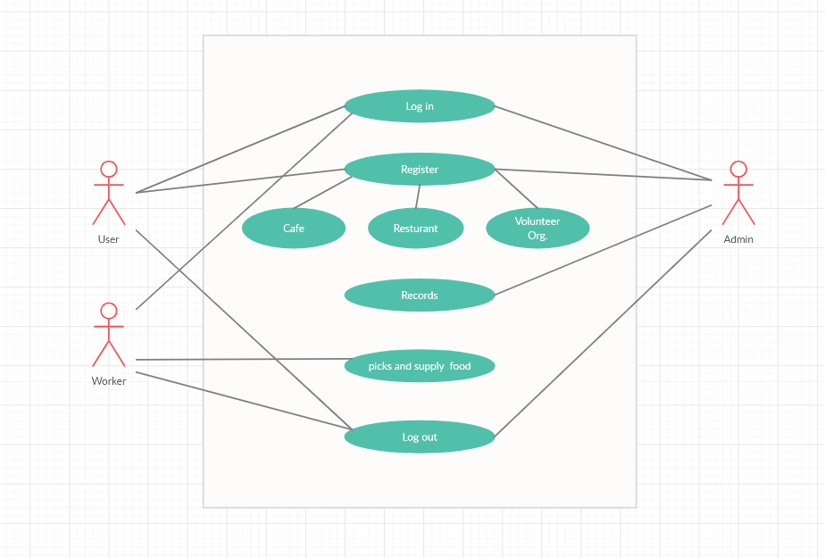

Use Case Specification:

|  |  |
| --- | --- |
| Use Case: | **Log in** |
| Actor: | Admin,User,Worker |
| Type: | Primary |
| Description: | Admin,User and workers first of all log in to the website and have proper rights that customer id who is inactive for many periods of times. |
| Includes: | none |

|  |  |
| --- | --- |
| Use Case: | **Register** |
| Actor: | Admin, User |
| Type: | Secondary |
| Description: | The admin and user have the rights to register Café, Resturant and volunteer organization that wants to help the needy people. the User have also the rights to register them. |
| Includes: | none |

|  |  |
| --- | --- |
| Use Case: | **Records** |
| Actor: | Admin |
| Type: | Secondary |
| Description: | Admin has the right to keep all the records of Café, Restaurant and volunteer organization for pickimg and distribution of food. Admin will maintain the records of needy peopleof different points. |
| Includes: | Manager must have to maintain the records. |

|  |  |
| --- | --- |
| Use Case: | **Picks and supply of food** |
| Actor: | Worker |
| Type: | Secondary |
| Description: | When the admin send request to volunteer organization they approves the request and assign the task of food collection to their workers.Worker picks up and leftover the food from restaurant and deliever it to register points of needy people |
| Includes: | none |

|  |  |
| --- | --- |
| Use Case: | **Log out** |
| Actor: | Admin, User, Worker |
| Type: | Secondary |
| Description: | Admin, User and workers have the proper rights to log out the account for safety and further usage. |
| Includes: | none |